**Signal to Noise Ratio and Contrast to Noise Ratio**

# Introduction

The purpose of this project is to explore Signal-to-Noise Ratio (SNR) and Contrast-to-Noise Ratio (CNR) in CT imaging. SNR measures the strength of the signal relative to the noise, while CNR evaluates the contrast between different structures or tissues relative to the noise level (**Fig 1.**).

In this project, we will focus on calculating the SNR and CNR within specific regions of interest (ROI) in CT images with a Cone-shaped Finger Phantom (**Fig 2.**).

Signal-to-Noise Ratio (SNR) is used to evaluate the clarity of the CT image. It is defined as:

$$\begin{aligned}SNR=\frac{μ_{o}}{σ_{o}}\#\left(1\right)\end{aligned}$$

where $μ_{o}$ is the mean attenuation coefficient of a defined structure (object) in the region of interest, $σ_{o}$ is the noise expressed as a variance of the pixel value of the targeted region of interest.

Contrast-to-Noise Ratio (CNR) is a measure used to specify image quality. It is defined as:

$$\begin{aligned}CNR=\frac{μ_{O}-μ_{B}}{\sqrt{σ_{o}^{2}+σ_{B}^{2}}}\#\left(2\right)\end{aligned}$$

where $μ_{B}$ is the mean attenuation coefficient of the image background surrounding this structure and $σ_{B}$ is the general background noise expressed as a variance of pixel value outside of the targeted region of interest.

|  |
| --- |
|  |
| ***Fig 1.*** *Plot of CT attenuation coefficient (μ) across an object of interest (O) surrounded by a background (B). The contrast is the difference in the average attenuation coefficients. The background noise is the standard deviation in the value of μ_B. Higher noise levels may still allow for an accurate diagnosis provided the noise level is not too excessive in comparison with contrast (∆μ>> σB) of a target region of interest* |

# EXPERIMENT

## Materials

* Cone-shaped Finger phantom (**Fig 2a**)
* 2L water
* DeskCAT Multi-slice Optical CT Scanner
* Collimator mask (**Fig 2b**)

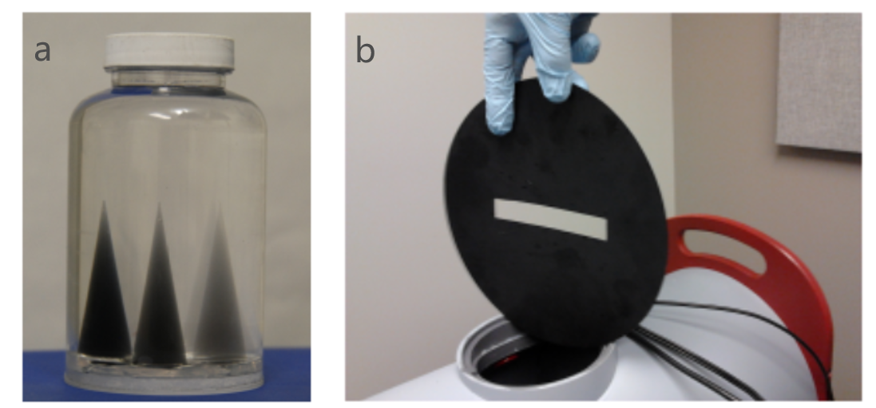

***Fig 2.*** *Cone-shaped finger phantom and collimator mask*.

## Experimental Procedure

1. Install a **Collimator mask** in front of the camera to capture data from the central slice. Please ensure that the slit in the collimator remains horizontal.
2. Adjust the camera setting to 50% of maximum brightness (reducing the brightness allows for evenly distributed noise) by selecting **Scanner -> Camera Settings (Fig 3.)**. **You can simulate different exposure times by adjusting this bar, to obtain projection data with varying doses.**

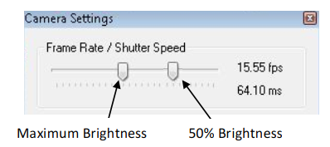

***Fig 3.*** *Camera setup diagram*

1. Under **Calibration $→$ Geometry Calibration** select Auto-Cal and accept the values. Calibration must be done with NO phantom loaded.
2. Set the Number of projections on the side panel to acquire data.
3. Do not place phantom $→$ click on the left sidebar to **scan reference data**.
4. **Load the Finger Phantom** into the scanner by attaching the phantom to the Rotary Stage using the Jar Clamp and mounting the Rotary Stage onto the scanner. Acquire a Data Scan using the Start Data Scan button on the Side Panel. Wait for the scan to complete.
5. Under Reconstruction $→$ Reconstruction Options, select **Hamming Filter.**
6. Select the Voxel Resolution option and press Start Reconstruction to perform a reconstruction. Observe the reconstruction results using the software.

# Reconstruction

## Dataset

## Data acquired

During the experimental procedure, first, install a Collimator in front of the camera to capture data from the central slice and ensure the slit in the collimator remains horizontal. The camera settings were adjusted to 50% of maximum brightness to ensure evenly distributed noise. Geometry calibration was then performed using the auto-calibration function, without any phantom loaded. Subsequently, the number of projections was set on the side panel for data acquisition, and reference data was scanned without placing a phantom. And the Finger Phantom was loaded onto the scanner and a data scan was acquired using the Start Data Scan button. Reconstruction options were configured to use a Hamming filter, and the reconstruction process was initiated by selecting the voxel resolution option and pressing Start Reconstruction. The reconstructed results were then observed using the software interface.

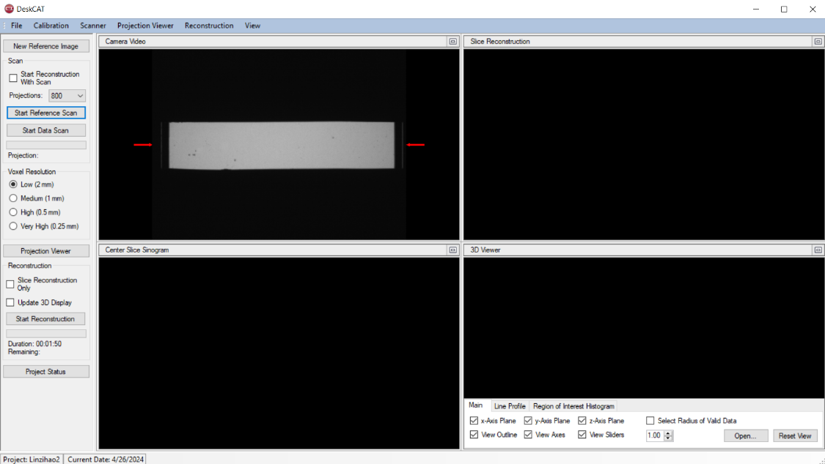

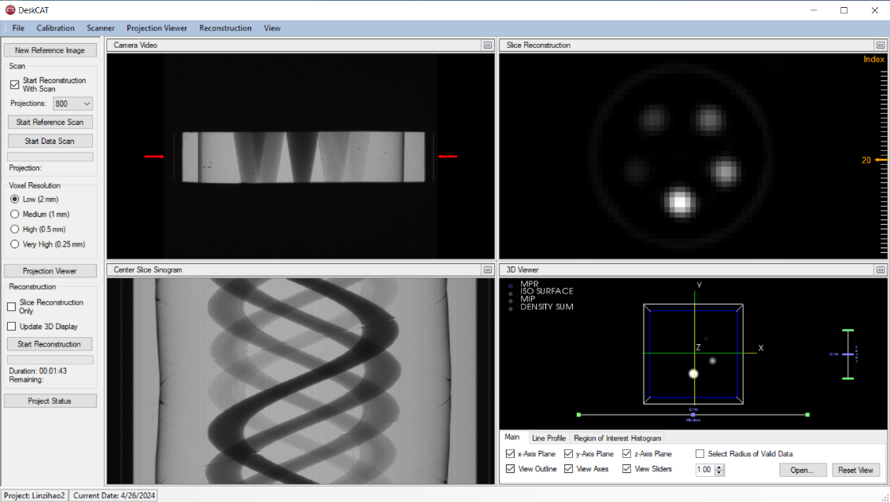

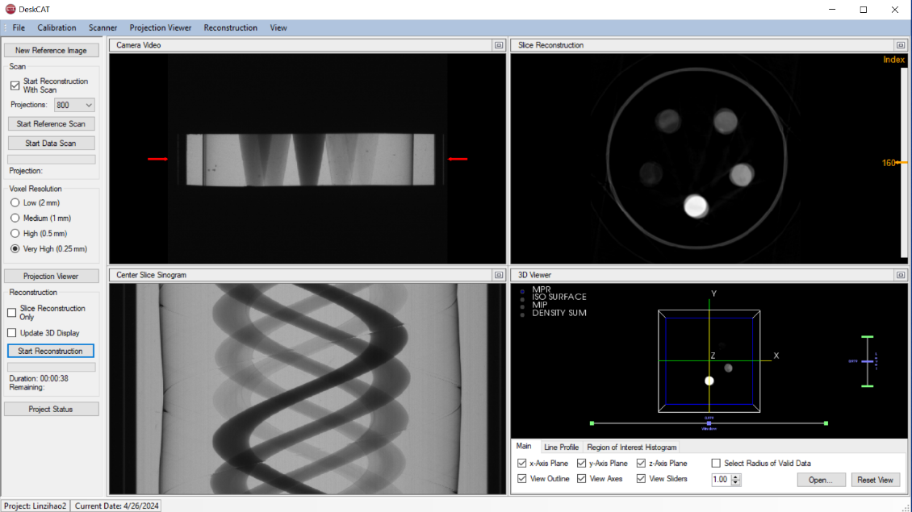

|  |
| --- |
| ***Fig 4.***  *Example of the data collection* |
| Parameters |

This project focuses on studying how Contrast-to-Noise Ratio (CNR) and Signal-to-Noise Ratio (SNR) change with varying radiation doses. To achieve this, we collected three sets of projection data under three different lighting conditions. Each set consists of 800 projections, with both projection data and background reference data for each angle. The geometric parameters crucial for data calibration and processing are as follows:

|  |  |  |
| --- | --- | --- |
| Parameter | Description | Value (cm) |
| SourceToAxis | Distance from the X-ray source to the rotation axis | 47.69 |
| AxisToDetector | Distance from the rotation axis to the detector | 4.5 |
| HorizLightSize | Horizontal size of the light beam | 9.95 |
| VertLightSize | Vertical size of the light beam | 7.46 |
| AxisOfRotationOffset | Offset of the rotation axis | 6.25 |
| EquatorialOffset | Equatorial offset | 0 |
| HorizPixelSize | Horizontal pixel size | 0.0006 |
| VertPixelSize | Vertical pixel size | 0.0006 |

1. **class** Paramaters:
2. **def** __init__(self):
3. self.param = {}
4. self.param['nx'] = 640  # image width
5. self.param['ny'] = 640  # image height
6. self.param['dect_count'] = 512  # number of detectors
7. self.param['dsd'] = 1500  # distance from source to detector
8. self.param['dso'] = 1000  # distance from source to object
9. self.param['nProj'] = 720  # number of projection views
10. self.param['startangle'] = 0  # start angle
11. self.param['endangle'] = 2*np.pi  # end angle
12. self.param['detector_width'] = 1  # detector spacing
13. self.param['algorithm'] = 'FBP_CUDA'  # reconstruction algorithm SIRT
14. self.param['interation'] = -1  # interations, only used in interative reconstruction algorithms
15. self.param['short_scan'] = False  # park compensation, only used in fanbeam and conebeam
16. self.param['noise'] = False
17. self.reuse = False

Using the provided geometric parameters, we can derive essential reconstruction parameters for accurate image reconstruction: Distance Source to Object (DSO), Distance Source to Detector (DSD) and Detector Width.

$$DSO=\frac{SourceToAxis}{ImagePixelSize},DSO=\frac{SourceToAxis+AxisToDetector}{ImagePixelSize}$$

where $ImagePixelSize=DetectorPixelSize×\frac{SourceToAxis}{SourceToAxis+AxisToDetector}$.

After the geometry calibration, the information of calibration and scan has been loaded in an XML file. Here are the details.

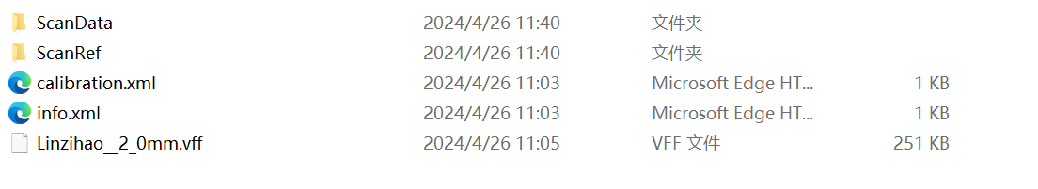

*Fig 5. Example of data acquired*

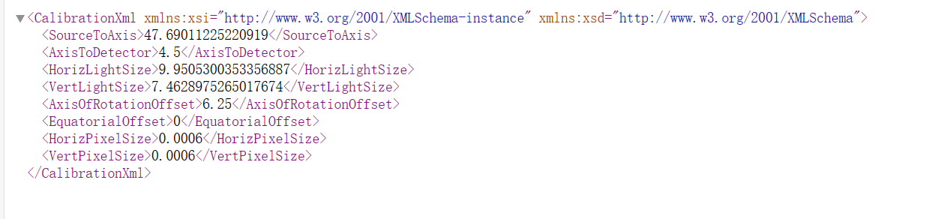

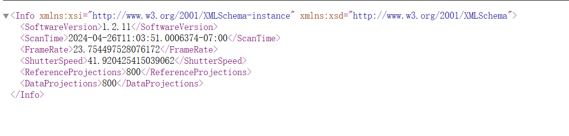

*Fig 6. Content of the calibration and information*

The part of the RefData and ScanData can also be shown here.

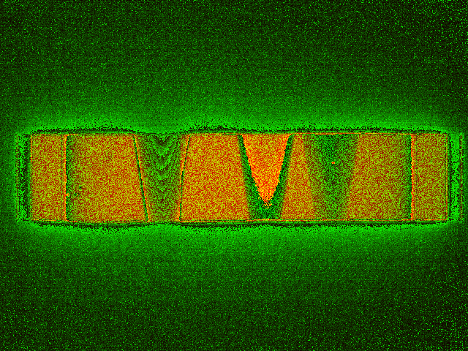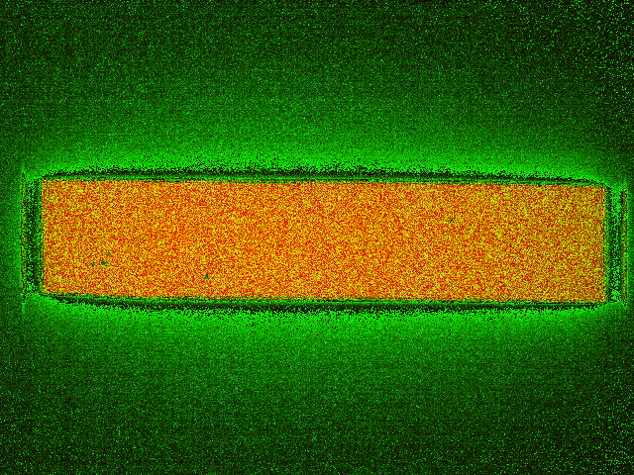

*Fig 7. Visualize the data acquired*

## Reconstruction Steps

The preprocessing part includes the following steps:

* **Get fan sinogram from the projection**

To obtain the sinogram, sum all the blank field projection data, get the middle data of the figure and calculate the average of the projection. Then take the middle row of each projection image sequentially, preprocess, and concatenate into a sinogram. After getting the sinogram, flat field correction should be done for preprocessing.

$$blank image data= \frac{sum of the blank image}{number of projections}$$

* **Flat field correction**

The blank field image is the image without the sample, while the dark field image is the image with the X-ray source turned off. Both images contain signals from the detector itself as well as background signals from other instruments. After the flat field correction, geometric correction could be used for correct detector for the final sinogram.

Corrected_field = $|\log\left(blank\right)-log⁡(projection)|$

* **Geometric correction**

The offsets provided by the system often have some deviation, requiring manual adjustment to achieve the best results.

Offset the reconstructed image 8 pixels upward and 5 pixels left

* **Filtered Back Projection**

In the FBP algorithm, the first step involves filtering the projection data using a specific filter kernel, commonly known the Hamming filter or ram-lak filter. The purpose of filtering is to remove noise and artefacts from the high frequency while enhancing contrast in the resulting image. Subsequently, the filtered projection data is back-projected into the image space. The back-projection process maps the filtered projection data back into the image space based on their corresponding angular positions, utilizing the reverse geometric relationships. By summing up the results of back-projection, the original structure information of the object can be reconstructed in the image space.

***FBP steps:***

(a) Radon Transform: Firstly, the projection data of the object in different directions is transformed into a representation in the spatial frequency domain using the Radon transform. This process captures the information of the internal structure of the object.

(b) Filtering: The projection data obtained from the Radon transform is filtered in the frequency domain to enhance high-frequency information and attenuate low-frequency information. This step compensates for the loss of low-frequency components in the projection data and suppresses artifacts and noise.

(c) Back Projection: The filtered projection data is back-projected based on the scan geometry information. Back projection maps the filtered projection data onto each pixel in the reconstruction image space, reconstructing the absorption distribution of the object in space.

(d) Reconstruction: Finally, the back-projected images from all angles are summed or averaged to generate the final reconstructed image. This process combines the back-projected images from different angles to form a three-dimensional absorption distribution of the target object.

The FBP algorithm in the ASTRA Toolbox can be simply used by

1. cfg_fan['option'] = {'ShortScan': short_scan}
2. **if** alg.startswith("FBP"):
3. cfg_fan["FilterType"] = filter
4. alg_fan_id = astra.algorithm.create(cfg_fan)

## Reconstruction Results

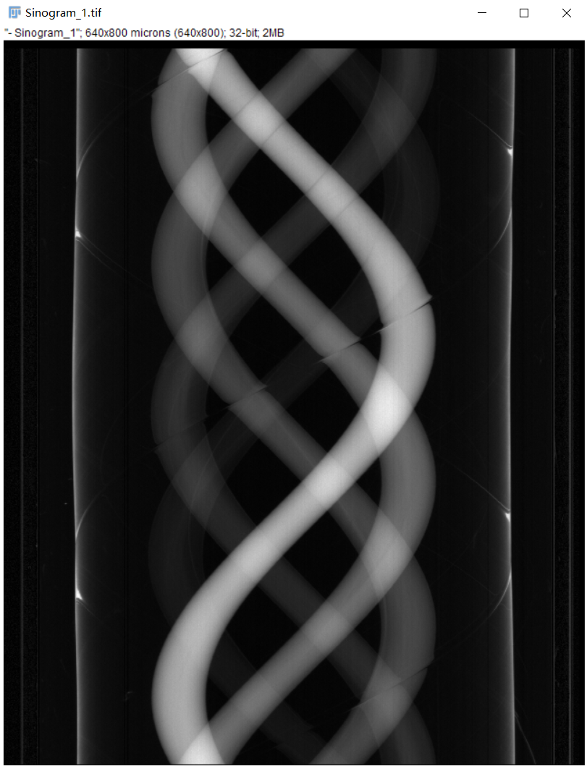

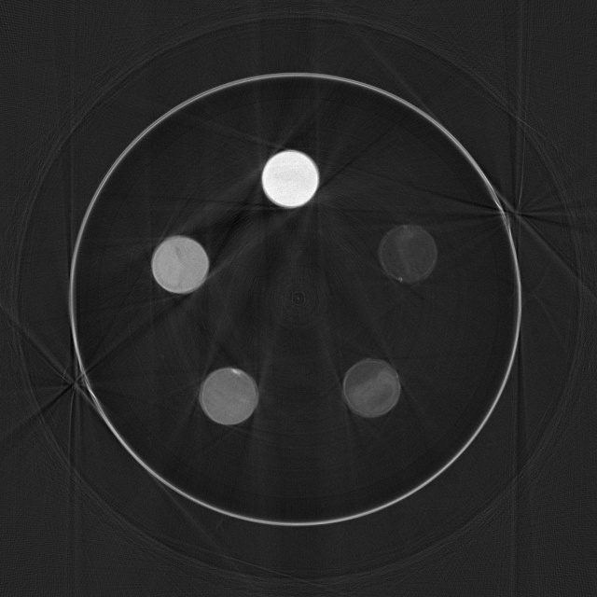

*Fig 8. Sinogram and reconstructed image from first scan*

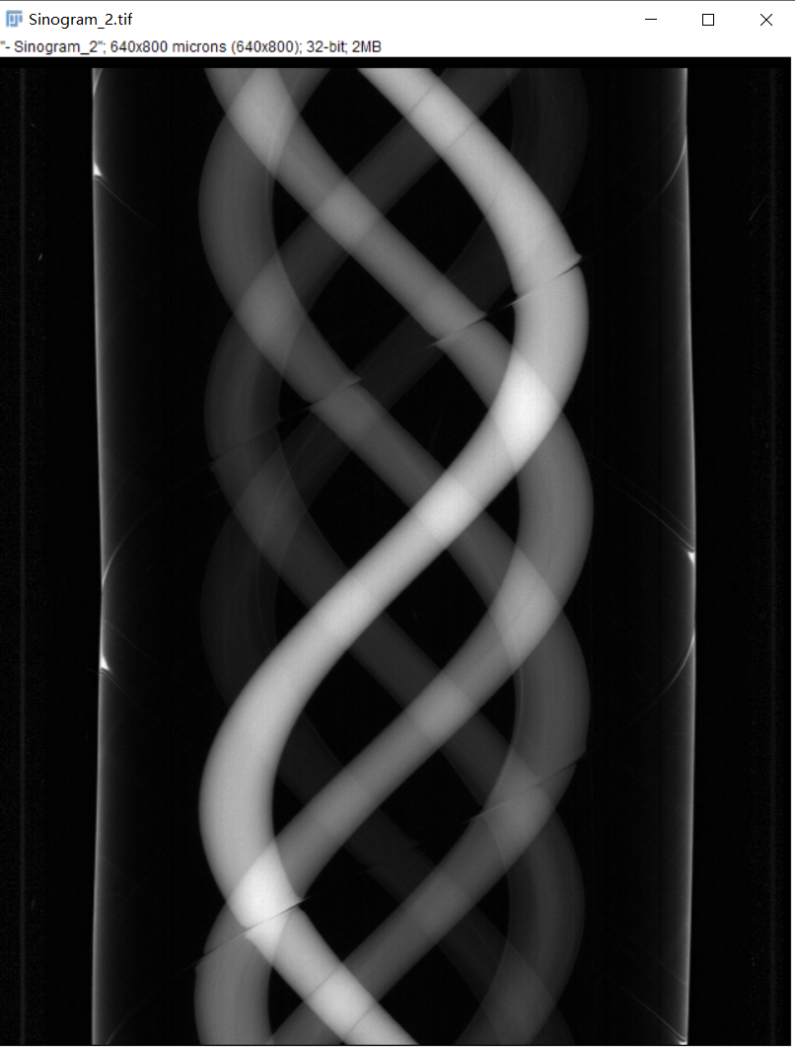

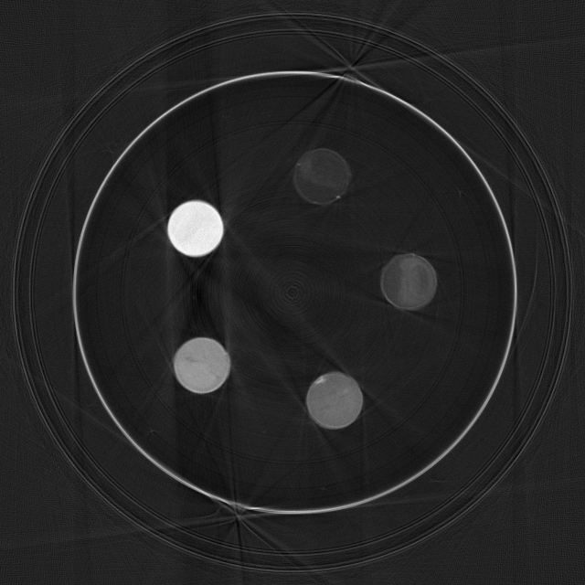

*Fig 9. Sinogram and reconstructed image from second scan*

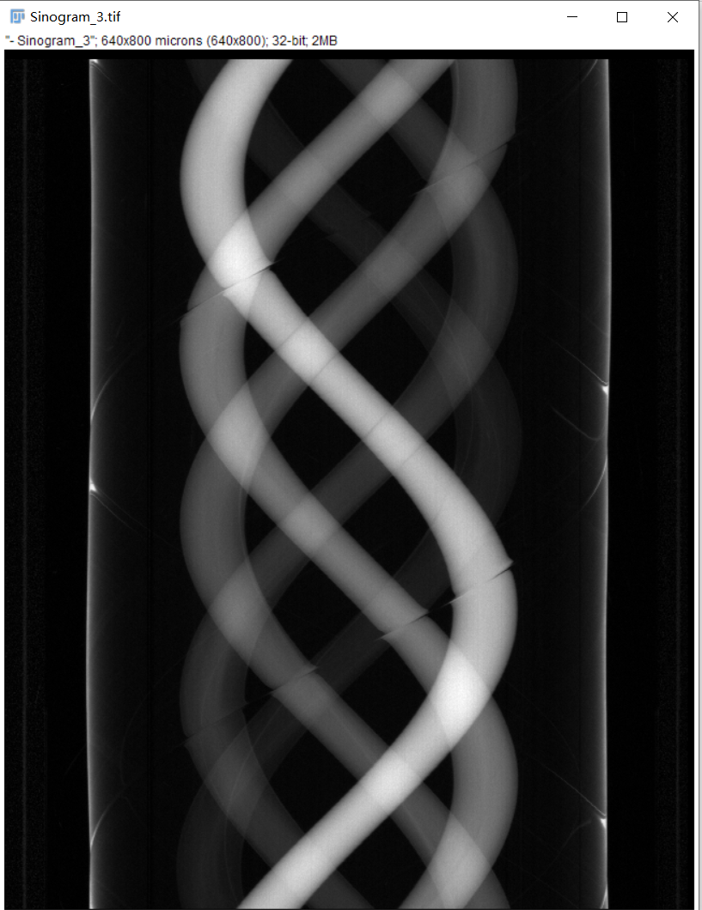

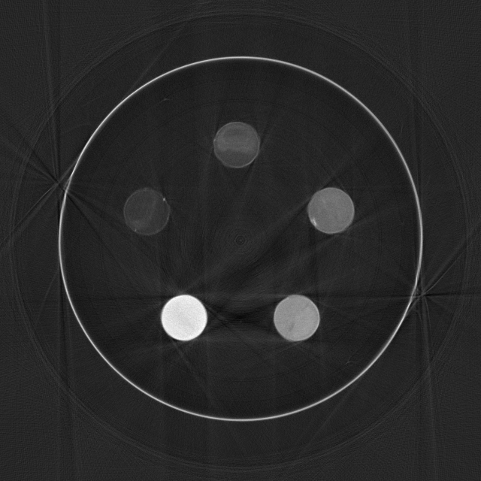

*Fig 10. Sinogram and reconstructed image from third scan*

# Analysis

To explore the role and principles of CNR and SNR in evaluating image quality in CT scans. The ROI 1 has been selected as the reference with the highest SNR. And compare the SNR and CNR of various ROIs.

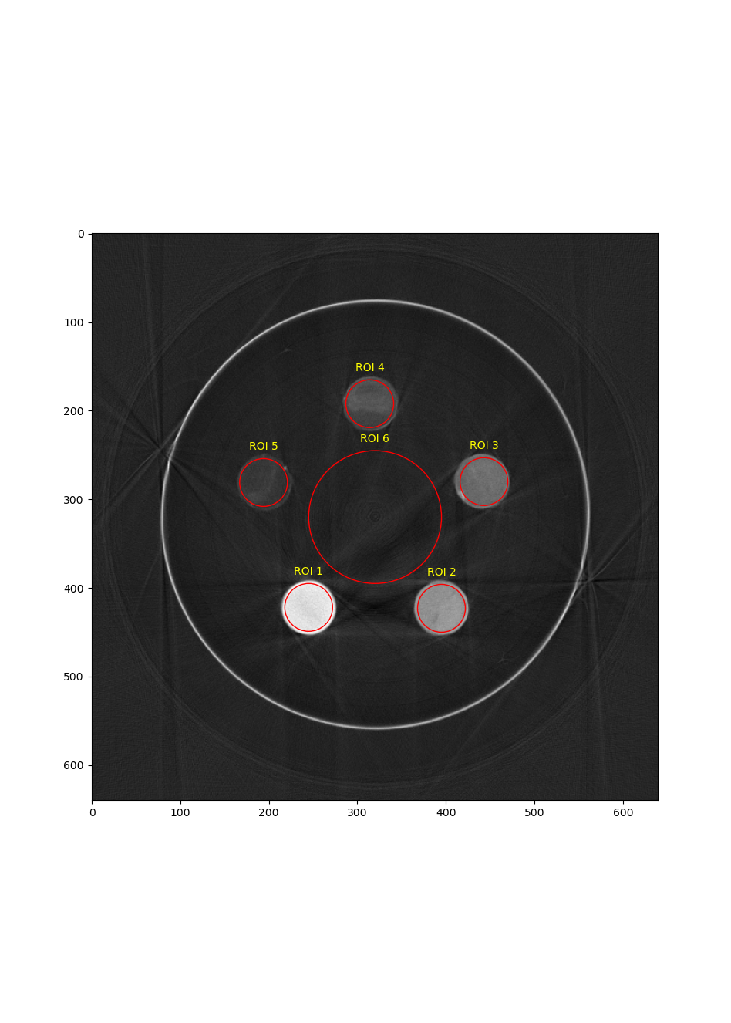

*Fig 11. ROI selected from the first reconstructed image*



*Table 1. SNR&CNR quantitative result from first image*

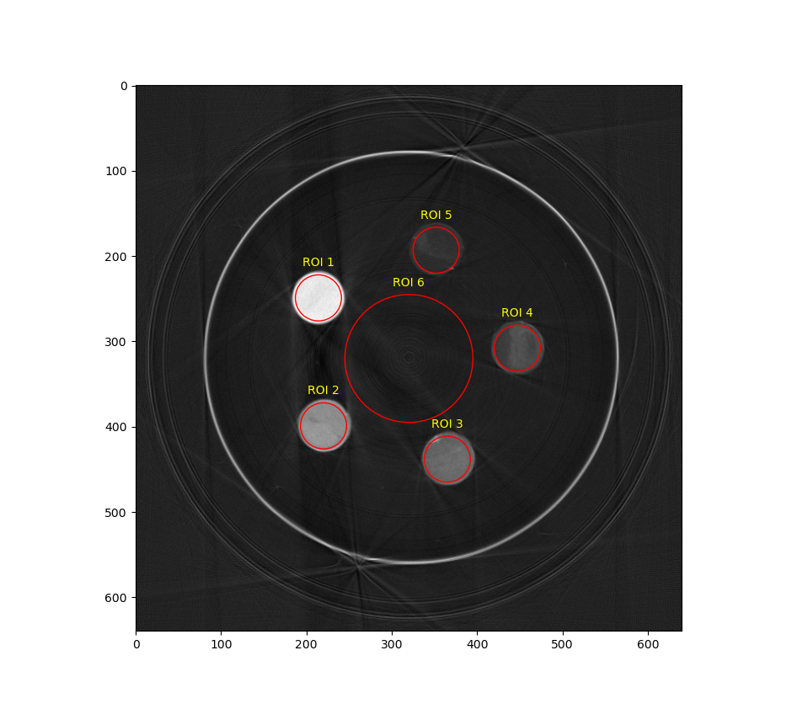

*Fig 12. ROI selected from the second reconstructed image*



*Table 2. SNR&CNR quantitative result from second image*

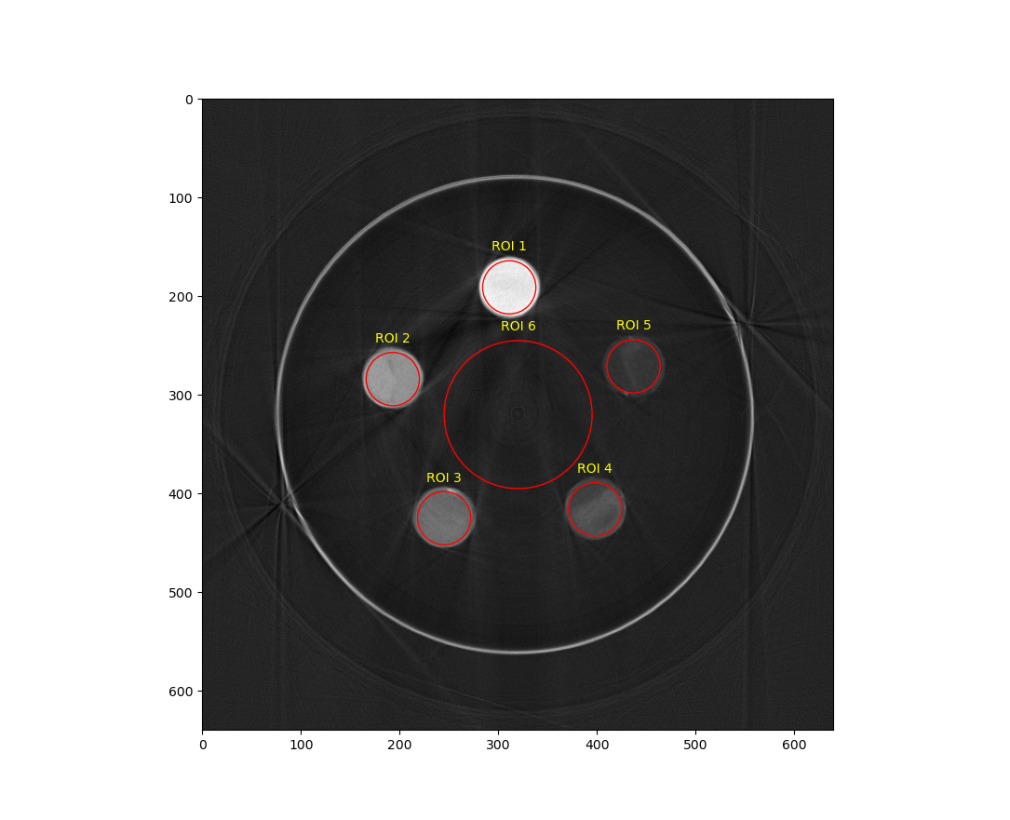

*Fig 12. ROI selected from the third reconstructed image*



*Table 3. SNR&CNR quantitative result from third image*

These results show that as the metering decreases, both the SNR and CNR of the ROI show a downward trend.

# Additional Question

By using different camera exposure times, you can obtain raw data with different amounts of photons (i.e. ‘radiation’ doses). How will CNR and SNR change with ‘radiation’ dose?